Friends of Central Park - Blue Sky survey 2024

Friends of Central Park’s annual ‘Blue Sky survey’ is an exercise to solicit the views of park users, to help guide FoCP’s activities and projects, and also to highlight concerns to the owners and managers of the park – Peterborough City Council and Aragon.
This year’s survey included the views of a total of 114 park users. This included 101 people who completed an electronic survey (sent out via the FoCP mailing list and also social media), and 13 people who were interviewed face to face at the Dog Show and Family Day in September 2024.
Thankyou to all the people who gave their time to complete the survey! Here are the results.

- Frequency of visit to Central Park
Survey respondents were asked ‘how often do you visit Peterborough Central Park?’ Nearly half of the respondents said they visited daily or weekly. This high level of engagement with the park lends weight to the rest of this report, as it’s evidence for the depth of knowledge many respondents have of the park, and also explains their affection, concern and passion for it.

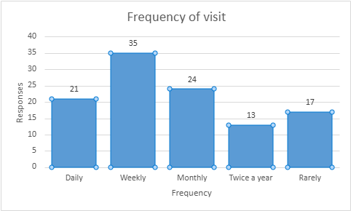

2: Activities in the park
Respondents were asked ‘What do you come to the park for?’ and they provided a wide range of responses (multiple responses per person allowed). Responses were classified as follows:

The most popular reason for visiting the park is to go for a walk with 52 responses, nearly a quarter of all responses. Going to the Willow Café was the second most popular reason.
General responses about ‘sport and exercise’ was the 6th most common response with 13 responses, but if combined with all the specific responses (ie. football, running, cycling, junior parkrun, basketball, table tennis, gym and badminton), ‘sport and exercise’ would have 31 responses, making it the second most popular reason.
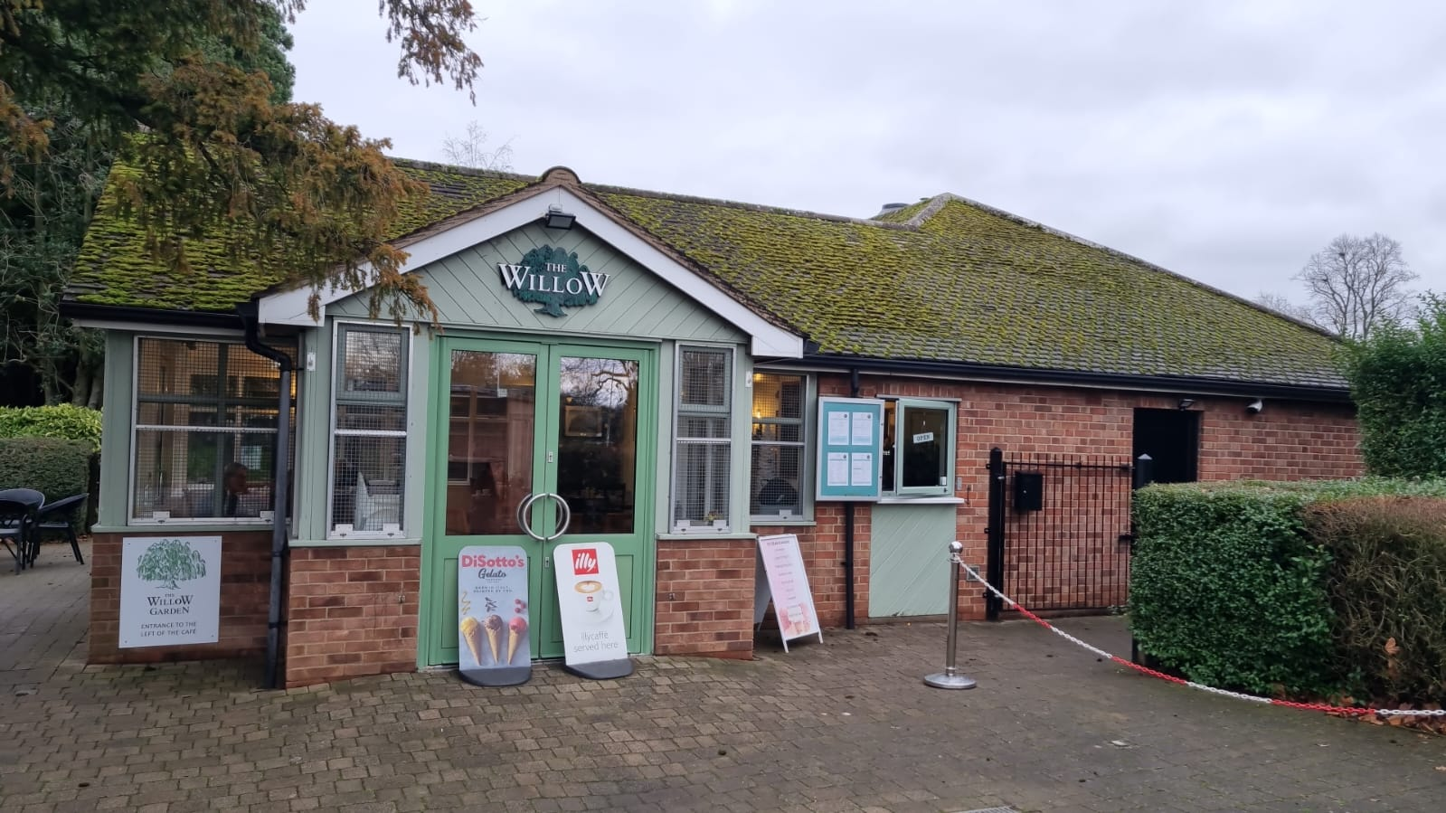

3: The best thing in the park
Respondents were asked ‘what is the best thing about the park?’ and they gave a large number of responses, which showed how well-loved and appreciated the park is.
It was difficult to analyse and categorise the wide variety of responses, but they could roughly be grouped under five headings. These headings and examples of responses are given below:
‘A place for nature’  69 responses | Comments about the natural and environmental qualities of the park: ‘It’s a beautiful green place’; ‘amazing trees’; ‘love the long grass’; the flowers, the birds (including the aviary); ‘big open spaces’, the squirrels; the landscaping (‘the landscaping is very attractive throughout the seasons)’; ‘plenty of fresh air’
Park management and location  36 responses | - The cleanliness and tidiness of the park - ‘always clean and well looked after’.  - Safety and peacefulness - ‘it feels a safe welcoming environment’ The availability of toilets, ‘so this doesn't limit time spent in the park’.  - The walkways – ‘I like the fact that you can walk a circular route and so does my dog, he hates to go over the same ground twice!’  - Easy access in the centre of the city  - Free parking  - Enough benches
‘A social place’  30 responses | Many comments about the Willow Café, but people also mentioned events in the park (‘there’s always something going on’), people-watching, the park being a place to meet up, and the inclusivity of the park – ‘It’s a great place for children, teenagers, and adults to have fun and actively spend their free time.’
‘A place for activities’  24 responses | Mentions of activities that people do in the park, including tennis, basketball, exercise and recreation, dog-walking and table-tennis.
‘A place for children’  20 responses | ‘Lots of activities for the kids’, the paddling pool, sandpit, the playground…

The comment on the right from one respondent encapsulates nicely many of the good qualities of the park!

‘The best thing about the park is the sense of freedom and relaxation it offers. It's a place where everyone, from the dog to the kids, feels at ease. You can enjoy open space for games, walking trails, fresh air, and quality time together. It’s the perfect mix of nature and fun!’

4: Suggestions for park improvements
Respondents were asked, ‘What could be improved about the park?’ This question was also very well responded to by participants, with 131 suggestions being made, including some well-considered, constructive ideas.
These suggestions have been categorised in twelve groups as follows:

The two themes that provoked the most comments were security and environmental, with 24 comments each. Some examples of comments are given below:
1. Security
- ‘Remove the drug dealers in the evening.’
- ‘You can often see drunk people sitting on the benches and drinking. CCTV would be a very good idea.’
- ‘Fewer groups of men drinking’
- ‘The benches in lowered garden park (the rockery part) after often full of groups of teenage boys smoking things they shouldn't. More visits from staff might prevent this.’
- ‘Unsavoury people who hang around in park, drunks, drug users’
- ‘Patrols ensuring anti-social behaviour is tackled quickly and effectively. This is not happening now. The Park can be an intimidating place as a result of this.’

4. Sport and youth
- Clubs for sporting activity - Tennis, Basketball, Pickleball (i think) volleyball etc. if they are in place I can't find them, if they are not can they be set up to build a group/ community around each sport?’
- ‘Maybe a skate park or basketball and obstacle course for children between 8 to 12 years old.’
- ‘More adventurous play equipment for older children.’
- ‘Putting football goals.’
- ‘A 5/76/7-a-side football cage with astroturf.’
- ‘More places for young people with sports games, e.g. basketball, golf.’
- ‘An improvement on the park exercise tools.’
3. Children’s play
- ‘Get the splash park working.’
- ‘Repair children's playgrounds, add more attractions.’
- ‘Increase the playground equipment for example a larger slide and swings for children above 5 years old.’
- ‘Special needs play area’
2. Environmental
- ‘More colourful planting areas’
- ‘Look closely at the awful "biodiversity areas" around the park margin. Biodiversity areas are positive but in most parks and green areas they are in open areas or around trees, not growing through low semi-formal shrubbery areas. The areas chosen in the park look a total mess, attract litter and dog poo as many dog owners feel it is unnecessary to clean up after their dogs in these unkept areas. They are a real negative aspect of our beautiful park.’
- ‘More flowers and plants, not as good due to council cuts.’
- ‘The flower beds could be sponsored so they could be planted up or plant them with wildflowers’
- ‘The sunken garden looks barren and neglected’
- ‘The leaves get swept and hot composted, which means that all of the tiny invertebrates in them are killed, including overwintering pollinators and food animals for larger creatures. Can they not be swept/blown into corners and left? Sucking them up with an industrial leaf vacuum will kill them, too. Actually I love to see the leaves just left where they are, though I appreciate that sweeping them from paths makes it safer for vulnerable people.’

9. Dogs
- ‘Have dogs on leads or a dog park. Would visit more if the dogs were on a lead. Have had dogs run and jump on us.’
- ‘I think it would be better if there was some way the park could better manage people with dogs, as often people let dogs run around unleashed and this can cause discomfort to people who are nervous around them.’
8. Toilets
- ‘Toilet too fast closing, sometimes 15.50 is closing.’
- ‘Updated toilets.’
- ‘Mirrors in the toilets.’
7. Park infrastructure
- ‘More benches on the grass. So you can watch the kids play closely.’
- ‘It would be nice if the water fountain between the Willow café and the gym was working again.’
- ‘Maybe drainage on the grassy areas, they can become soggy if you walk over them if dragged by the dog!’
- ‘Big cracks in the paths that need repairing.’
6. Cleanliness
- ‘I have seen many times when families with children come, have picnics, then get up and leave, leaving all the garbage behind! I think we need some small signs so that people don't litter and teach their children!’
- ‘Unfortunately it’s not possible to keep the park clean. We visit most morning for a walk. The refuse is unsightly and ugly but obviously discarded in the evening. The takeaway wrappers that are thrown away on the roads outside the park are another eyesore that the council cannot keep clean due to happening in evenings.’
- ‘More trash cans’
- ‘Maybe few signs to tell everyone to put rubbish in the bin.’
5. Events
- ‘I think more fun days for families with children, live music or shows.’
- ‘More events like the dog show and family fun days.’
- ‘More music and theatre events, evening events.’
12. The aviary
- ‘The aviary is in bad condition’
- ‘Put toys in aviary.’
11. Willow café
- ‘Lower prices in the park café.’
- ‘The café could be open for longer.’
10. Others
- ‘A park warden to ensure law and order is maintained and to stop litter louts’.
- ‘Disabled parking in the park, near the cafe would be a great addition’
- ‘Information on what's on more easily available.’

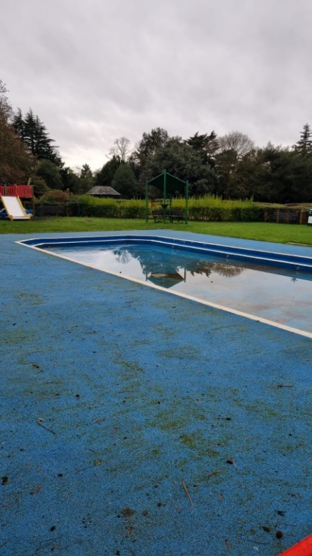
5. The paddling pool
Respondents were asked, ‘Do you use the paddling pool? If so, what do you think about the paddling pool provision?’ 39% of respondents answered that they do, or did, or would use the pool (given that it’s opening has been so erratic in recent years). There were many sad and angry comments about the paddling pool provision:
- ‘It’s a great shame that it has not been maintained as it is a significant attraction to small children.’
- ‘It was very sad that this summer the paddling pool was closed. Bretton paddling pool was closed as well. I remembered beautiful times before Covid, people has a picnic around paddling pool and kids played in the water.’
- ‘I had to stop coming with my kids to Central Park because they wanted to play in that paddling pool or small playground (pirate ship) and I was tired about explain why they can’t. It was so frustrating.
Even people who said they don’t use it would like to see it back: ‘We don't really use it but it is nice to see it in use in the summer. It's a shame that there are so many issues with the pump.’
A few people made reference to the well-publicised issues around getting spare parts: ‘make sure all parts are available before the height of season.’
6. Aviary
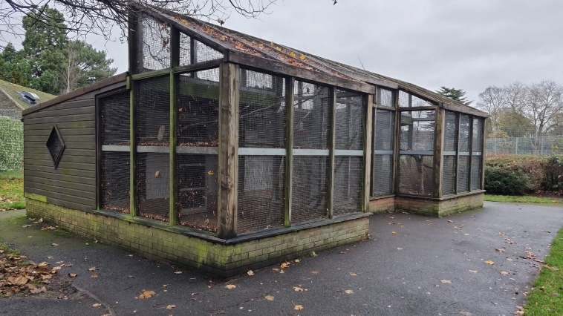
Respondents were asked ‘Do you ever visit the aviary? What do you think about this attraction?’
81 respondents (71%) said they have visited the aviary.
59 respondents (52%) made positive comments about the aviary, eg:
- ‘Kids love it. It’s nice hearing the birds’
- ‘Absolutely amazing. I love birds and always my first visit is to see aviary’
- ‘Yes, I visit it every time I come to the park’
- ‘Residents from care homes who visit the park like it’
- ‘It's quite nice. At least the birds have room to fly and seem happy’
- ‘My dog enjoys the birdsong.’
22 respondents (19%) made negative comments about the aviary:
- 9 respondents commented on the maintenance of the aviary, eg. remarking that it was dilapidated and in need of repair
- 7 respondents expressed concerns about animals being in cages, the size of the space or the health of the birds
- 4 respondents mentioned the lack of variety of birds and the low number of birds
- 3 respondents commented that there was poor signage and the aviary was hard to find
- 1 person requested there to be toys added to the aviary.

7. The survey’s respondents
The survey asked a few questions about the respondents themselves, to assess whether the responses were representative of Peterborough residents as a whole and whether the interests of different groups were represented.

7.1: Age

Over half of the respondents were in the 40-60 age-group. Older people (61+) were well represented. It was disappointing that only 4% of respondents were under 20, especially as the survey has been distributed to a school. This shows that more work is needed to engage with young people, especially as it is clear that the park is well used by young people.
7.2. Gender
73% of respondents were female while 24% were male, which shows the need to get more male views in future surveys.
7.3. Ethnicity
Half of the respondents identified as white British (or English), but there were also sizeable numbers from two other ethnic groups: European (including various Eastern European countries) and Pakistani/South Asian (including British Pakistani, Indian and Bangladeshi). This reflects that Central Park is used by a wide cross-section of Peterborians, and is evidence that the survey represents the diversity of areas surrounding the park such as Millfield and Gladstone.

7.4. Disability
8% of respondents said that they had a disability, or had a family member with a disability who used the park. This is rather low, as anecdotal evidence suggests that the park is well used by people with disabilities. This suggests that the survey may have been inaccessible, and more accessible methods and approaches should be used in future surveying.

Report compiled by Steve Harknett, Secretary, Friends of Central Park
With thanks to Cheryl McGuire for photos, and for Kelly German and young people of Thomas Deacon Academy for assistance with surveying.

